The Confederated Tribes of Grand Ronde and Spirit Mountain Community Fund are pleased to announce Sharon Flegal, Joshua Kibbey and Nell Best-Shipway as the 2023 yeʔlan lima (Helping Hand) award winners.
Each year, the Spirit Mountain Community Fund selects three individuals (an unpaid volunteer, a paid staff member, and a paid management member) doing incredible work in the nonprofit sector to receive our annual yeʔlan lima award. (In our Chinook language, yeʔlan lima means Helping Hand.) Each award recipient receives a special award, a free night stay and dinner for two at Spirit Mountain Casino, and a check in the amount of $500 for their outstanding efforts to helping those in need.

Paid Management: Nell Best-Shipway ~ Hope and Safety Alliance
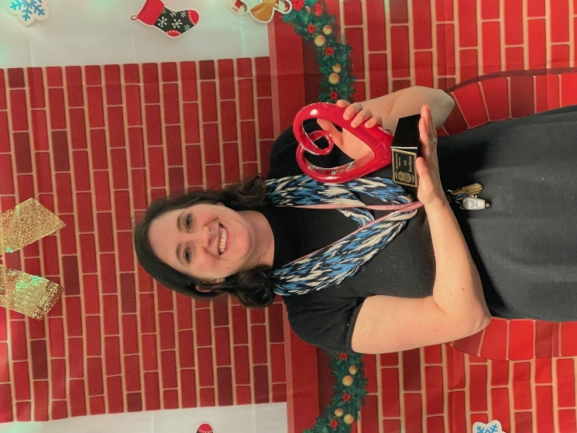

Paid Non-Management: Joshua Kibbey ~ Luckiamute Valley Charter School
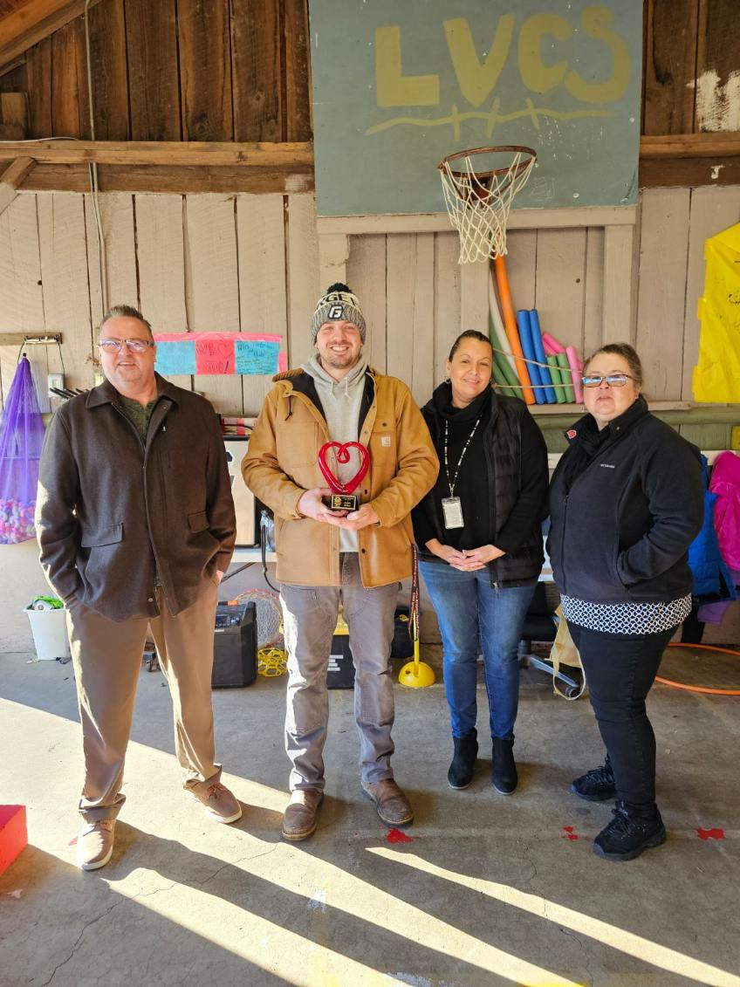

Non-Paid Volunteer: Sharon Flegal ~ Returning Veterans Project
